

**Tribhuvan University**

**Faculties of Humanities and Social Sciences**

**ONLINE FOOD ORDERING SYSTEM**

**A PROJECT PROPOSAL**

**Submitted to**

**Department of Computer Application**

**Ratna Rajya laxmi Campus**

**Pardashani marga, Kathmandu**

***In partial fulfillment of the requirements for the Bachelors in Computer Application***

**Submitted by**

Krishna Prasad Bharati

December, 2023

Table of Contents

INTRODUCTION 4

PROBLEM STATEMENT 5

OBJECTIVES 6

METHODOLOGY 7

a. Requirement Identification 7

i) Study of Existing System 7

ii) Requirement Collection 8

b. Feasibility Study 9

c. High Level System Design 11

GANTT CHART 12

EXPECTED OUTCOME 13

REFERENCES 14

# INTRODUCTION

The ambulance reservation system serves as a platform enabling customers to promptly secure ambulance services during emergencies. It establishes a direct link between patients and hospitals, acting as a seamless medium for their connection. This facilitates efficient and simplified delivery of assistance to patients in need.

This system ensures that patients receive prompt and appropriate medical attention and care, which is essential in saving lives. The system is user-friendly, ensuring patients can quickly book an ambulance and receive the care they need. The system also helps to alleviate overcrowding in hospitals, as ambulances can be dispatched to areas where needed more quickly and efficiently. It also allows for more accurate tracking of patients, providing better patient care. An emergency situation could arise at any time with no warning. It could jeopardize and bring significant injuries on a person’s life. Saving someone in an emergency situation demands sophisticated and organized rescue planning thus, this system helps to ensure that patients receive the necessary treatment in a timely manner. Furthermore, it helps to reduce costs associated with manual booking and check-in anywhere within the country.

The main goal is to maintain the hospitals function in an effective and accurate manner and to make it easier to book ambulances. This helps hospital to maintain day to day records of system. It can be used to create a proper database of all the people who have used the ambulances. I propose an online ambulance system originally designed for use in any hospitals

# PROBLEM STATEMENT

The challenges encountered by the existing system serve as a major drawback to the realization of efficiency and customer satisfaction. The experience of reserving an ambulance in most hospitals is not pleasant for the customers. Customers will be very panicked and scared when ordering an ambulance. The user interface can also be complicated which leads to people not being able to submit requests. There is also lack of service for ambulances outside the valley. Furthermore, most hospitals operate by manually reserving the ambulance. This leads the process being much more tedious and harder for people. Hospitals in rural area cannot use complicated systems. This system will make the process of reserving ambulances much easier.

Hospitals are very competitive businesses as well as one of the most important services to people. An ambulance is an extension of a hospital. The lack of ambulances leads to a lot of deaths in our nation. This system will aim to be user friendly as well as extremely easy to use. This will also fix the problem of complex user interface in the system. Some hospitals do not provide adequate information about the ambulance operator and also do not provide adequate bills. The contact information of the drives is also not provided. This system aims to make the process of reserving ambulances fast, easy to use, transparent and makes it so that ambulances can be reserved all over Nepal.

# OBJECTIVES

The primary goal of this project is to develop a comprehensive platform that provides ambulance users with a seamless and accessible service interface. This platform is designed to empower users to efficiently request and access ambulance services in emergency situations, ensuring a swift and timely response to their critical needs. By creating a user-centric system, we aim to enhance the overall experience of ambulance service utilization, prioritizing ease of use, accessibility, and prompt assistance during urgent medical scenarios. To establish a user-friendly online platform for individuals to request ambulance services. Main objectives of ambulance reservation system are:

* To facilitate the reservation and dispatching process, reducing response times during emergencies.
* To enhance the overall efficiency of emergency medical services.

# METHODOLOGY

## a. Requirement Identification

We have used some of the secondary sources in order to meet the requirements of our project.

### i) Study of Existing System

The existing system refers to the system that is currently being followed by the hospitals and currently running other ambulance reserving systems. Presently all the functionalities are done manually. If a customer wants to reserve an ambulance, they should visit the hospital or call the related hospital to get the ambulance to the location. This makes the process quite difficult and tedious since they must stay in queue. The main disadvantage is that it is time consuming and it makes it difficult for the manager to know the customer's past history. So, the system should be digitized, where the customer can book an ambulance online through the website. The hospital manager should be able to access the customer's past history easily and the system should be able to provide accurate data. This would increase efficiency and make the process of booking an ambulance much simpler

**Problems of Existing System**

* While reserving ambulances, simple errors can be made
* There are problems contacting the ambulance after it has been dispatched
* It is time consuming for the customers to reserve ambulances
* The record keeping system is poor which might cause loss of vital records of the past.

**Advantages of Proposed System**

To overcome the restrictions of the above system, Online Food Ordering System is proposed which has the following advantages:

* People can successfully reserve ambulances using the proposed system.
* There will be a lesser requirement of staff at the hospital.
* The system will help in sending ambulances to remote area.
* All the records of the current and ex-patients will be stored in the database.
* The customers can avoid the long queues at the counter.

## ii) Requirement Collection

To develop the proposed system, a requirement analysis was conducted by considering insights from past researchers and existing systems. Essential data was gathered through the examination of manuals and existing systems, forming the basis for the system. A theme was chosen, and subsequent tasks were initiated. The integration of the system followed the completion of tasks. Once the goal was established, the requirement collection process commenced to gather information about the history of the online ambulance reservation system and previous works in this domain. Various methods were employed for requirement collection, including:

* Literary Analysis

Various works of literature have undergone thorough analysis to ascertain the nature of recommendations put forth in previous studies. These contributions have played a pivotal role in identifying the deficiencies in prior solutions and delineating the goals and objectives of the project.

* Observation

A multitude of hospital websites have undergone examination to discern the prevailing trends in developing web applications for ambulances. Concurrently, an exploration of standard ambulance ordering systems has been conducted to gain insights into the workings of online reservation systems.

* Study of manuals

Manuals and reports related to the online ambulance reservation system were acquired and thoroughly examined, yielding substantial information regarding the envisaged system to be developed.

* Brainstorming

The team members employed brainstorming as a creative and idea generation technique. Through this approach, certain system requirements were gathered, contributing valuable insights to the development process.

## b. Feasibility Study

The analysis of feasibility has concluded that the project can be done within the expected time and budget. The technology used to develop are mostly Open-Source technology for development, which means lower costs for both getting the project started and maintaining it in the long run.

* **Technical**

Our system implementation is flexible, capable of adapting to a variety of existing technologies and is crafted to seamlessly integrate with any upcoming technologies that might emerge

**Hardware Requirements:**

·       Processor: 800MHz Intel Pentium III or equivalent (or newer)

·       Disk space: 50MB or more

·       RAM: 128MB or more

·       Software Requirements:

·       Operating System: Windows (7 or newer)

**Web Browser:**

IE 10 or above, Mozilla Firefox and above, or Google Chrome XAMPP, MySQL

**Programming Languages Used:**

     HTML, CSS, PHP, MySQL, JavaScript

* **Operational**

Operational feasibility focuses on how well the system tackles challenges and takes advantage of opportunities identified during its initial scope definition. Fortunately, the project is considered operationally feasible.

·       The existing mode of operation demonstrates commendable throughput and response time.

·       The proposed system is expected to bring substantial benefits to the organization.

·       the available resources are optimally utilized, ensuring the delivery of a high-quality system within the established timeframe.

* **Economical**

This aims to evaluate the positive economic benefits that the proposed system will bring to the organization.

·       The system is cost-effective.

·       The streamlined management of rehouses will reduce the overall expenses associated with this system.

·       The advantages derived from this system are expected to outweigh the associated costs.

## c. High Level System Design

1. **System Flowchart**

The system flowchart of online food ordering system is shown as follows:

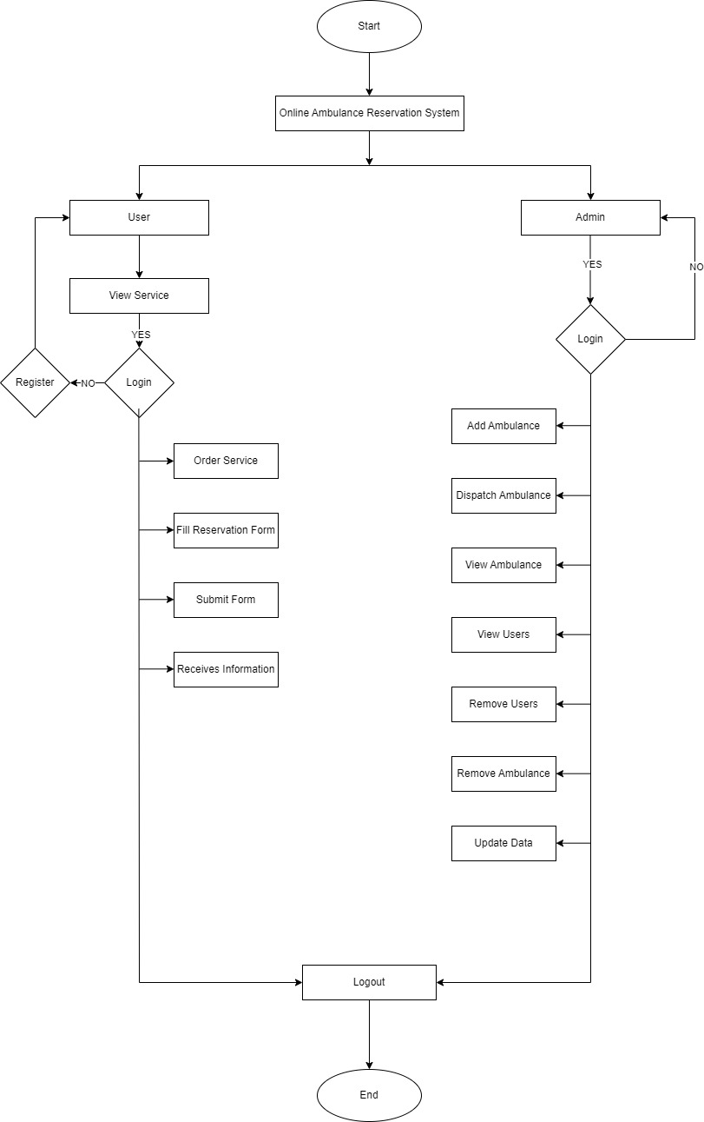

**Figure 1: System Flowchart of Online Ambulance Reservation System**

# GANTT CHART

|  |  |  |  |  |  |  |  |  |  |
| --- | --- | --- | --- | --- | --- | --- | --- | --- | --- |
|  | Start Date | End Date | 1 | 2 | 3 | 4 | 5 | 6 | Status |
| Planning | 25 Dec | 5 Jan |  |  |  |  |  |  | Active |
| Analysis | 27 Dec | 7 Jan |  |  |  |  |  |  | Active |
| Design | 8 Jan | 12 Jan |  |  |  |  |  |  | Up coming |
| Coding | 13 Jan | 29 Jan |  |  |  |  |  |  | Up coming |
| Testing | 1 Feb | 13 Feb |  |  |  |  |  |  | Up coming |
| Documentation | 25 Dec | 13 Feb |  |  |  |  |  |  | Up coming |
|  |  |  |  |  |  |  |  |  |  |

We intend to launch our project, commencing from the second week of Paush 2080. The planning phase will span until the conclusion of Paush. Concurrently, the analysis phase will initiate. As this phase approaches its conclusion, our attention will turn to data modeling, where we will attain clarity on entities, attributes, key features, cardinality, and the overall process of our system. Following data modeling, we will immerse ourselves in process modeling by crafting Data Flow Diagrams (DFDs) and their respective levels. Subsequently, we will transition to the design phase in the final week of the Magh month, instigating the design of the Graphical User Interface (GUI) in the ultimate week of Paush. In the latter segment of the design phase, we will establish the database for our system.

Immediately after the design phase, we will commence coding the system in the first week of the Magh month. This phase is expected to conclude in approximately a month. Testing procedures will kick off in the midst of the Magh month, continuing even after the system is fully coded. Therefore, testing will persist until the initial week of the Falgun month. Acknowledging the importance of documentation in our system, we will initiate documentation from the project's inception, i.e., the second week of Paush. However, the creation of comprehensive documentation will only transpire after the conclusive testing phase of our system.

# EXPECTED OUTCOME

After the completion of the project, we expect the subsequent outputs which can minimize the issues likewise as solve the prevailing problem.

* Easy online access for users to request an ambulance, reducing the need for phone calls and paperwork.
* A transparent system able to disclose important information.
* Users can schedule ambulance services anywhere within the country at their convenience for medical appointments, hospital transfers, or other non-urgent situations.

# REFERENCES

# Bibliography

|  |  |
| --- | --- |
| [1] | A. KUMAR, "php gurukul," [Online]. Available: https://phpgurukul.com/gym-management-system-using-php-and-mysql/. [Accessed 10 9 2023]. |
| [2] | A. KUMAR, "php gurukul," [Online]. Available: https://phpgurukul.com/how-to-compare-two-dates-in-php/. |
| [3] | R. S. Saud and M. Giri, Software Engineering, KEC, 2077. |
| [4] | S. B. Saud and I. Chaudhary, DataBase Management System, KEC, 2023. |
| [5] | N. Bajracharya, "Gym Management System in PHP MySQL," [Online]. Available: https://codeastro.com/gym-management-system-in-php-mysql-with-source-code/. [Accessed 20 May 2023]. |
| [6] | draw.io, "Flowchart Maker & Online Diagram Software," app.diagrams.net, [Online]. Available: https://app.diagrams.net/. |
| [7] | GAMAGE, "Web based Gym Management System," [Online]. Available: https://dl.ucsc.cmb.ac.lk/jspui/handle/123456789/3899. [Accessed 2023]. |
| [8] | abc, "man," 18 april 2003. [Online]. [Accessed 5 jan 2024]. |